**Discovery 2: Analyze Cisco Express Forwarding**

**Introduction**

In this discovery lab, you will verify Cisco Express Forwarding operations. You will inspect both the FIB and adjacency table, and see how their content updates to reflect changes in the control plane. You will also learn how to enable and disable Cisco Express Forwarding.

**Task 1: Analyze Cisco Express Forwarding**

**Step 1:** Inspect the content of the FIB and adjacency tables on the HQ router.

You can use show ip cef and show adjacency enable-level commands to verify FIB and adjacency tables, respectively.

On HQ, enter the following commands:

HQ# show ip cef

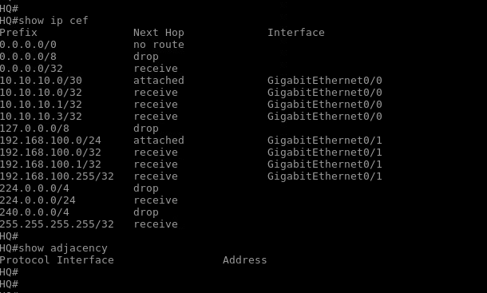

You can notice that there is an entry in the FIB table for every network that HQ knows about—that is, for every entry in the routing table, there is already a preconfigured entry in the FIB table. Because HQ is currently not configured with any routing protocol, only local networks are present in the routing table. Router HQ has no information about remote network 192.168.110.0/24.

However, the adjacency table contains no entries. The adjacency table is built from the ARP table. Because you have not generated any traffic yet, there are no entries in the ARP table, and, therefore, the adjacency table is also empty.

**Step 2:** Initiate traffic on the HQ router toward the neighboring router BR1 using ping. Verify the content of the adjacency and FIB tables.

On HQ, enter the following commands:

HQ# ping 10.10.10.2

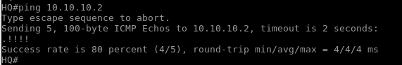

Notice that the first packet was lost. This packet loss is because the HQ router was waiting for an ARP reply from BR1, which is needed to complete a new ARP entry on HQ.

On HQ, enter the following commands:

HQ# show adjacency

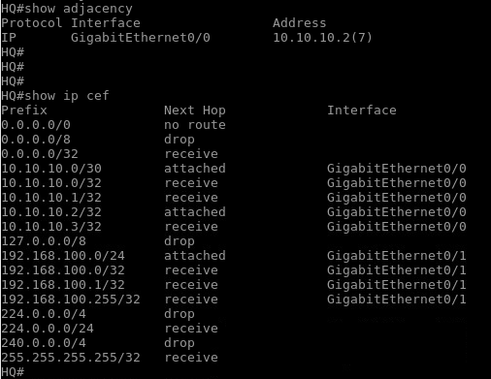

Notice that the adjacency table changed as the HQ router learned about the new end host via the ARP protocol. As a consequence, the new entry is also inserted into the FIB table.

**Step 3:** Turn on EIGRP on the HQ router. BR1 is already configured. When the routing adjacency is up, verify that new routes were received.

On HQ, enter the following commands:

HQ(config)# router eigrp 1

HQ(config-router)# network 0.0.0.0

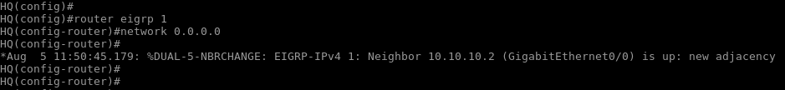

As you can see from the final line of the output, EIGRP adjacency is up.

On HQ, enter the following commands:

HQ# show ip route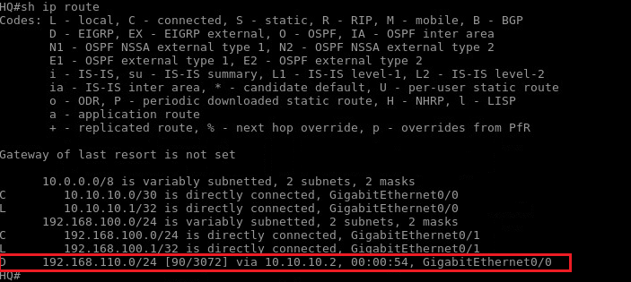

**Step 4:** Verify the FIB and adjacency tables again.

On HQ, enter the following commands:

HQ# show ip cef

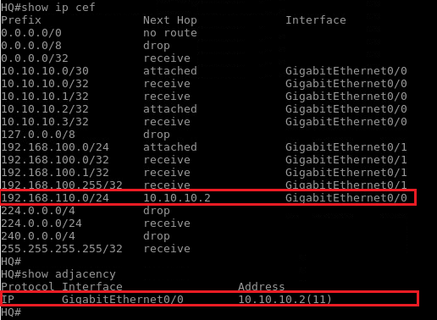

Notice that now the FIB table has a new entry for the 192.168.110.0/24 network. This new entry is because the routing table changed when a new route was learned via EIGRP. On the other hand, the adjacency table remained the same, which was expected because the ARP table did not change.

**Step 5:** Verify that Cisco Express Forwarding is enabled for interface GigabitGigabitEthernet0/0 on the HQ router.

You can use the show ip interface **interface** command to verify the Cisco Express Forwarding status of the particular interface.

On HQ, enter the following command:

HQ# show ip interface GigabitEthernet0/0

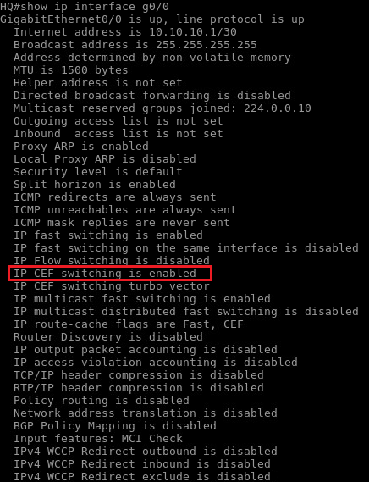

Notice the line "IP CEF switching is enabled" in the output, which tells you that Cisco Express Forwarding is enabled on this interface. Cisco Express Forwarding for IPv4 is enabled, by default, on all interfaces with the global-level ip cef command. Cisco Express Forwarding should be used whenever possible. You might need to disable Cisco Express Forwarding when you experience some problems and need to troubleshoot the issue.

Cisco Express Forwarding for IPv6, on the other hand, is not enabled by default. However, it is enabled automatically when you enable IPv6 unicast routing on your devices. As a prerequisite, IPv4 Cisco Express Forwarding must be enabled to use IPv6 Cisco Express Forwarding.

**Step 6:** Disable Cisco Express Forwarding on interface GigabitEthernet0/0 on the HQ router. Verify that Cisco Express Forwarding is disabled on the interface.

You can use the **no ip route-cache cef** interface-level command to disable Cisco Express Forwarding on a particular interface.

On HQ, enter the following commands:

HQ(config)# interface GigabitEthernet0/0

HQ(config-if)# no ip route-cache cef

HQ(config-if)# end

HQ# show ip interface GigabitEthernet0/0 | include CEF

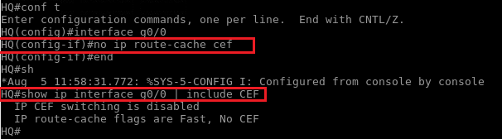

Notice the line "IP CEF switching is disabled," which confirms that Cisco Express Forwarding is disabled on the interface.

**Step 7:** Disable Cisco Express Forwarding globally on the HQ router. Verify that Cisco Express Forwarding is disabled globally.

You can use the no ip cef global-level command to disable Cisco Express Forwarding on all interfaces of the router. You can verify whether Cisco Express Forwarding is enabled globally with the show ip cef command.

HQ(config)# no ip cef

HQ(config)# end

HQ# show ip cef

